Converting Windows OS BIOS Mode from Legacy BIOS to UEFI on a VM

Creating WIN PE
- Creating the bootable WIN PE ISO only needs to be done once. It will be reused for each computer that you want to convert.

- Download and install Windows Assessment and Deployment Kit with WIN PE Tools
  - You only need to install Deployment tools
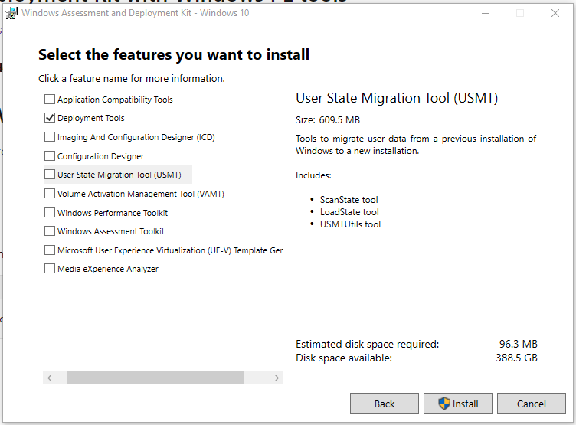
- Then install WINPE Addon
- Create WIN PE
  - https://docs.microsoft.com/en-us/windows-hardware/manufacture/desktop/winpe-create-usb-bootable-drive
  - Start the deployment and imaging tools environment as an administrator
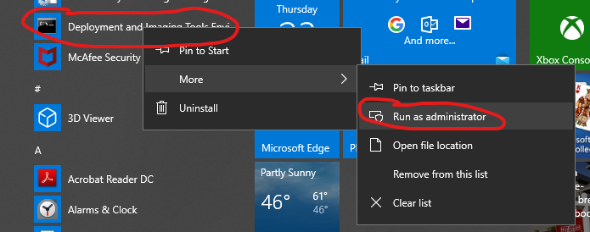
  - Create WINPE working files
    - CopyPE amd64 <Path>
      - Where path is a directory you want to create the file
  - To complete the following you can do it manually or modify the included Build WINPE.PS1 script
    - https://docs.microsoft.com/en-us/windows-hardware/manufacture/desktop/winpe-mount-and-customize
    - Mount the Image
    - Add Powershell to the WINPE Disk
      - https://docs.microsoft.com/en-us/windows-hardware/manufacture/desktop/winpe-adding-powershell-support-to-windows-pe
    - Copy the powershell scripts to the scripts directory (you will have to create the directory first)
      - ConvertTo-UEFI.ps1
      - Write-Log.ps1
    - Add MBR2GPT to the WINPE Files
      - For some reason the MBR2GPT that comes with the WINPE 1909 didn’t work. So I copied the one from my WIN 10 1803 machine to a new directory in the Mount folder.
      - Copy from the c:\windows\system32 directory to the Scripts directory
    - Edit the windows\system32\startnet.cmd and add the following line to the end
      - Powershell -executionpolicy bypass -file c:\scripts\convertto-UEFI.ps1
    - Dismount and commit the image
    - Create Bootable ISO
      - MkaeWINPEMedia /ISO <Path> <path and name of new ISO>
      - The script uses OSCDIMG.exe to do the same
Upload to vCenter Datastore
- Again you can do this manually or the script has this included.
Automated Converting VM BIOS
- The WINPE ISO that we just created will run a script to convert the BIOS to UEFI automatically.
- The UEFIVCenter.ps1 script will automate the process of
  - Creating Snapshot
  - Mounting ISO on the VM CDROM
  - Changing the VM BOOT Order
  - Booting into WINPE
    - Here the WINPE Script takes over and converts to UEFI OS
    - Shuts down the VM
  - Once the VM is shut down this script continues
  - Changing the VM BIOS to EFI
  - Setting the boot order back to original
  - Starting the VM in UEFI mode.

Manual Example Converting VM BIOS
- Create a snapshot of the VM. If the VM does not boot after the conversion, you can restore the snapshot to recover the VM to before the conversion.
- Mount ISO to VM
- Reboot to WINPE ISO
- Determine the System disk this will be used in the next step
- Validate against the system disk
  - MBR2GPT.EXE /validate /disk:0
  - if no errors continue
- Convert the disk
  - MBR2GPT /convert /disk:0
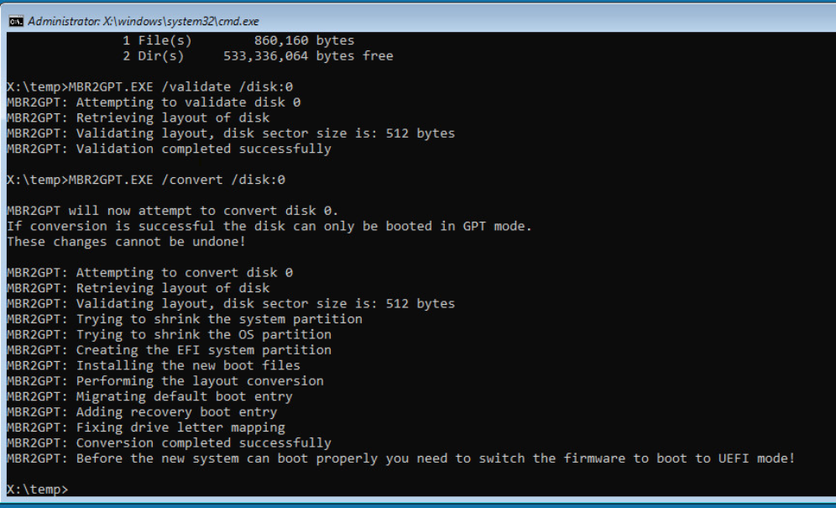
- Power off VM
- Change the Hardware Firmware in VMware
  - Edit Settings
  - VMOptions
  - Boot Option
  - Firmware
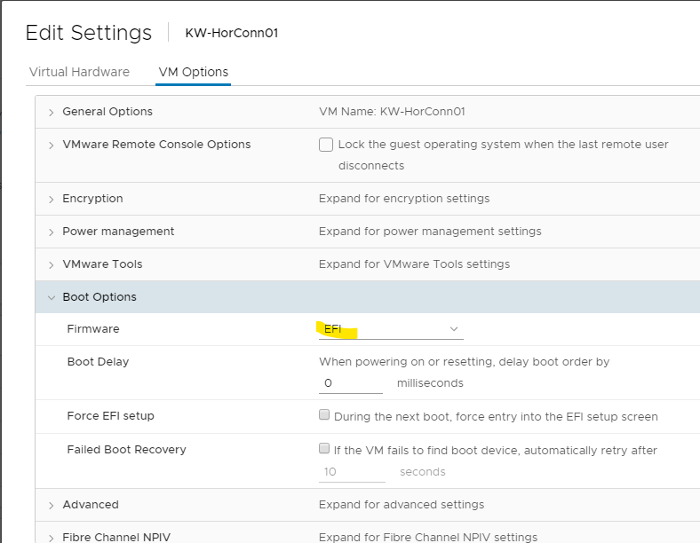
- Boot Server

Verify Windows is booting with UEFI

GUI
- Log into windows
- Run MSINFO32.exe
- Check the BIOS Mode
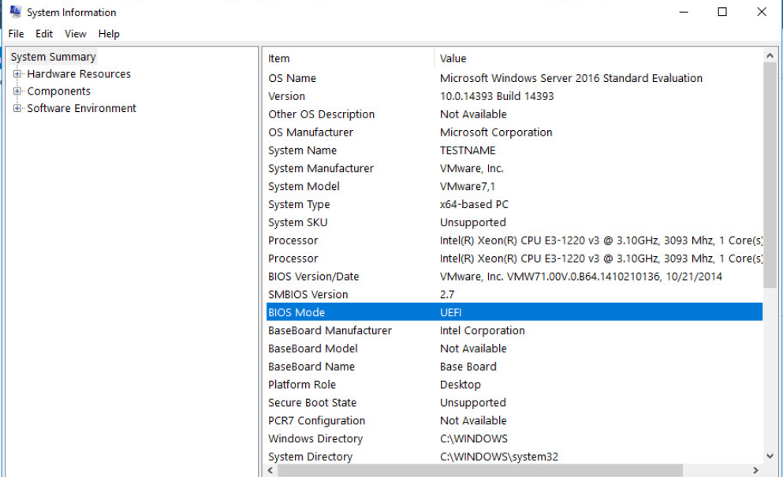

PowerShell
- This can also be used with a list of computers to see which machines have been converted and which need to be completed
Invoke-command -ComputerName $C -Scriptblock { Get-ComputerInfo | Select-Object BIOSFirmwareType }
